Successful Completion of SIXTH Vaccination Camp
SIXTH COVID 19 Vaccination Camp was organized in Shiv Jyoti Public School for the Students of 12 + age group on 30/7/2022.
•Principal Mrs. Neeru Nayyar motivated the students & Parents to vaccinate themselves.
•Around 150 Students & Teachers were successfully vaccinated.
•Principal Mrs. Neeru Nayyar thanked & appreciated the initiative taken by the Health Department.
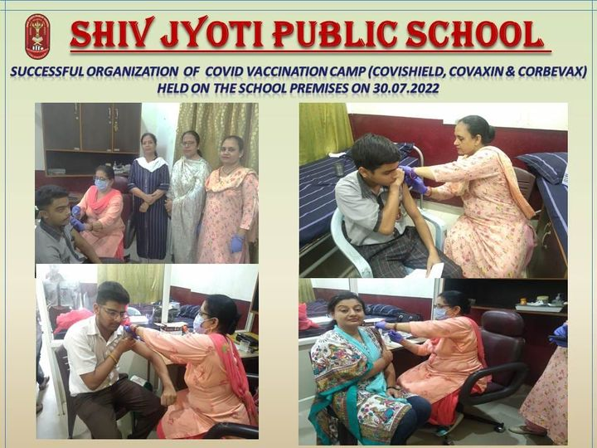

CELEBRATION OF GURU PURNIMA
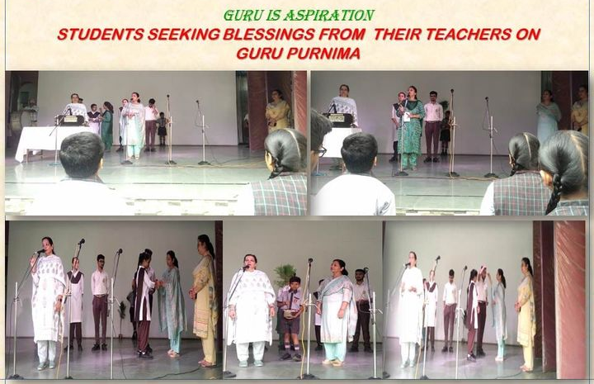

International Day of Yoga 2022
Under International Day of Yoga,21st June 2022, Shiv Jyoti Public School organised various Activities during the span of one and a half month. Students and Staff members participated in the event with their full zeal and enthusiasm.
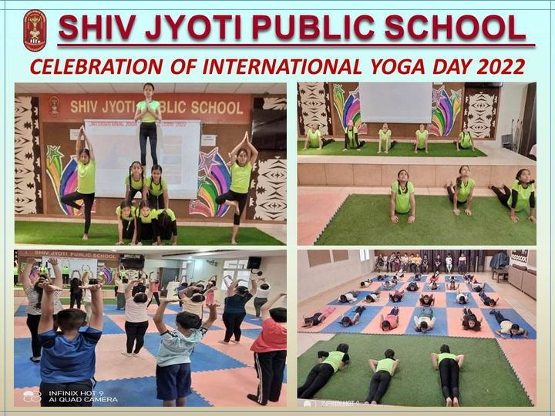
Students even participated in Inter School Yoga Competition held at DAV School Bilga, under the ageis of Jalandhar Sahodaya. Mass Yoga session was also conducted and videos on Yoga were shown to the students. On the Foundation Day of the School, students presented a song item of Yoga based on the theme Azadi ka Amrit Mahotsav and also made Human Pyramids through various Yoga postures.
Celebration of World Environment Day2022 on 5th June
Educators of Shiv Jyoti Public School have stepped forward to spread awareness amongst the students to conserve our lifeline----The Environment.
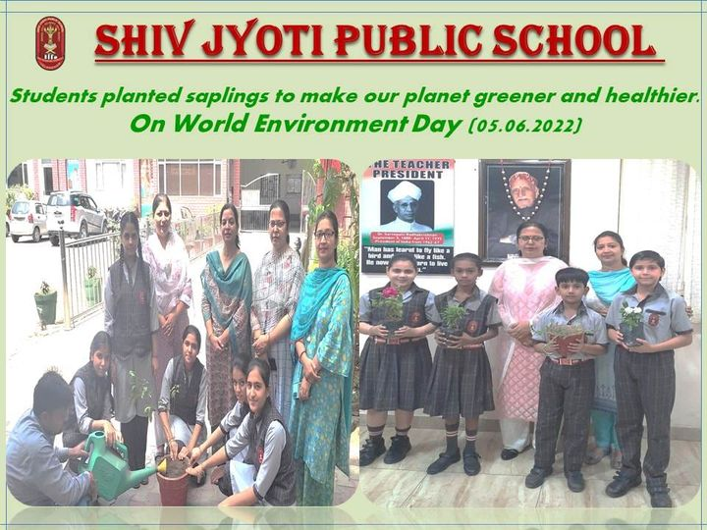
To create awareness among students and make them realize their responsibility towards their environment, Students of classes 4th, 5th, 6th & 11th took an initiation to make environment green by planting saplings & help them grow big by taking care of them.
World No Tobacco Day
World no Tobacco Day is observed around the world every year on 31 May. This yearly celebration informs the public on the ill effects of using tobacco. This day was also observed in Shiv Jyoti Public School.
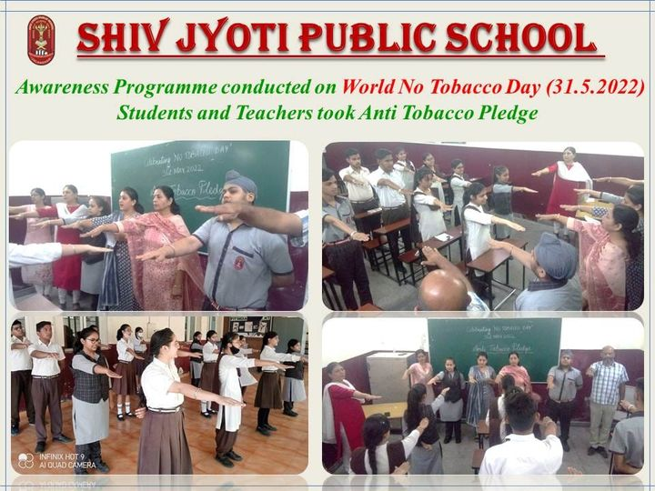
Madam Principal Mrs.Neeru Nayyar addressed the students to make them aware of the ill effects of Tobacco consumption. Students and Teachers took Anti Tobacco Pledge with madam Principal.
Successful Completion of FIFTH Vaccination Camp
FIFTH COVID 19 Vaccination Camp was organised in Shiv Jyoti Public School for the Students of 12 + age group on 12/05/2022.
•Principal Mrs. Neeru Nayyar motivated the students & Parents to vaccinate themselves.
•Around 208 Students & Teachers were successfully vaccinated.

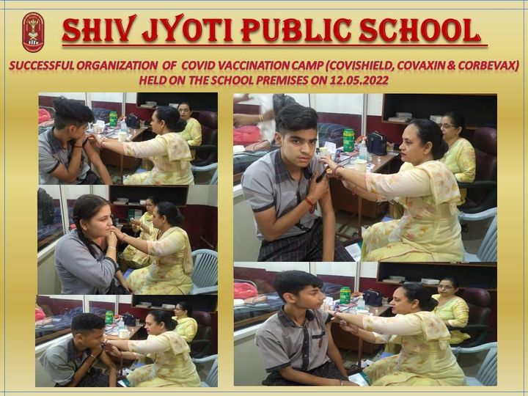
Mother's Day Celebration
Motherhood is a million little moments that God weaves together with grace, redemption, laughter, tears and most of all love. Mother's Day was also celebrated in Shiv Jyoti Public School with great zeal and enthusiasm by the students.
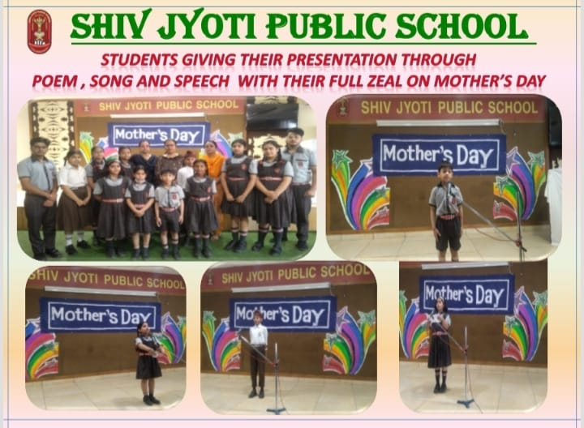
In Morning Assembly, students from different classes presented their feelings by reciting poems, giving speech and through songs. Muskan of VIII A gave speech on Mother's Day. Hyaan of IA and Aaradhya of VA recited poems .
Adoloscent Peer Educators Leadership in Life Skills, Health & Well Being Program Module-II
Health and well Being club of Shiv Jyoti Public School conducted Module -II (Growing Up Healthy & Family Bonding) under 'Peer Life Skills Leadership Program in Life Skills, Holistic Health & Well-being' as proposed by CBSE. Under the able leadership of the school management and Principal Mrs. Neeru Nayyar around 194 students of Class -IX participated in this activity.
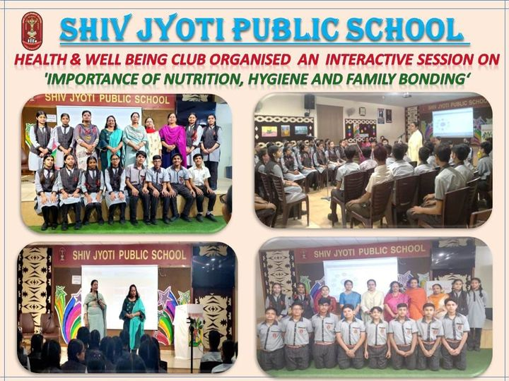
Under this activity, Mrs. Sarita Kapoor made students aware that a healthy body breeds a healthy Mind & Vice Versa. Proper food intake will provide good nutrition; good hygiene practices will help in better utilisation of food to lead a productive & healthy life. It was technically supervised by Ms.Guninder.
Inter House English Poetical Recitation Competition
Inter House English Poetical Recitation Competition for classes 9th to 12th was held on 30/4/22. The participants put forth their enthralling performance. Total 35 Participants took part in Competition. The Final judgement was made by Mrs.Neenu Singh & Mrs.Megha Kumar
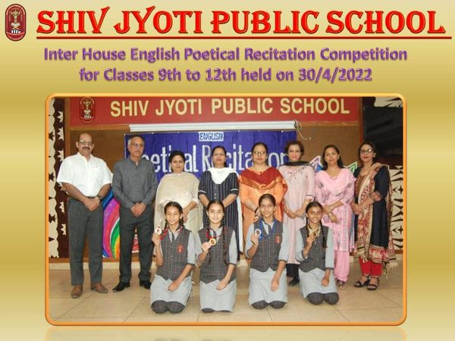
Inter House Punjabi Poetical Recitation Competition
Inter House Punjabi Poetical Recitation Competition for classes 6th to 8th was held on 29/4/22. The participants put forth their enthralling performance. Total 37 Participants took part in Competition. The Final judgement was made by Mrs.Balwinder Kaur & Mrs.Shama Sharma.
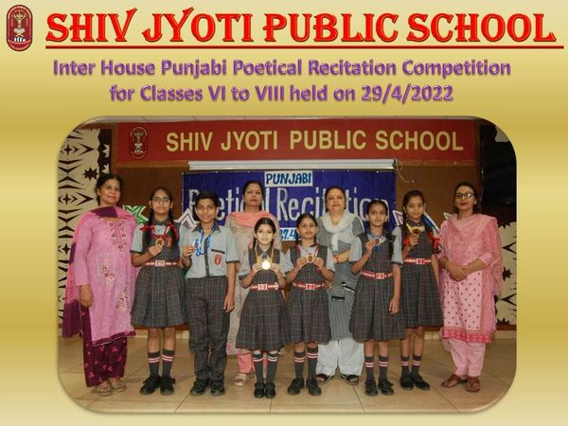

Successful Completion of FOURTH Vaccination Camp
FOURTH COVID 19 Vaccination Camp was organised in Shiv Jyoti Public School for the Students of 12 + age group on 02/05/2022.
•Principal Mrs.Neeru Nayyar motivated the students & Parents to vaccinate themselves.
•Around 252 Students & Teachers were successfully vaccinated.

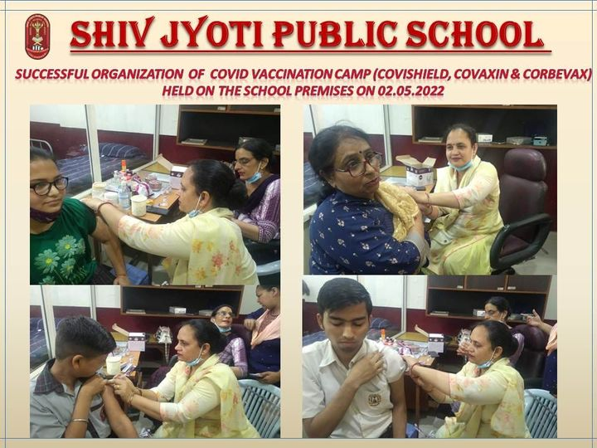
Inter House Hindi Poetical Recitation Competition
Inter House Hindi Poetical Recitation Competition for classes 1st & 2nd was held on 28/4/22. The participants put forth their enthralling performance. Total 37 Participants took part in Competition.
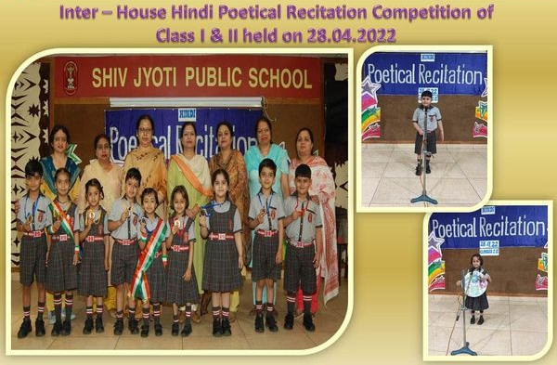
Inter House Hindi Poem Recitation Competition
Inter House Hindi Poem Recitation Competition for classes 3rd to 5th was held on 27/4/22.There were total 55 participants shortlisted for competition. The participants put forth their enthralling performance.
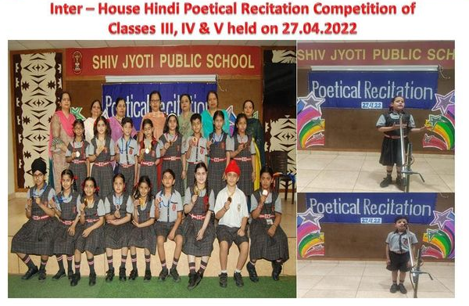
Celebration of Valedictory Function
To wish success to students for their bright future, Shiv Jyoti Public School celebrated Valedictory Function of Class XII with the blessings of Mrs. Krishna Jyoti (Chairperson), Dr. Vidur Jyoti (Chairman, Trust) and Dr. Suvikram Jyoti (Manager, Managing Committee & General Secretary, Trust) under the patronage of Principal, Mrs. Neeru Nayyar.
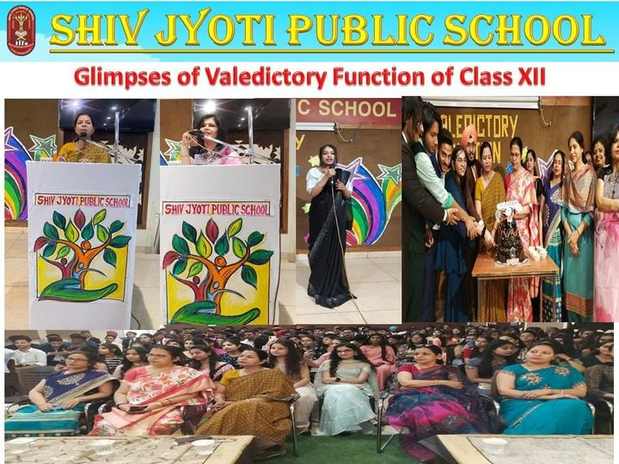
Celebration of world book day 2022
World Book Day,also known as World Book & Copyright Day, is an annual event organised by the ‘UNESCO ‘to promote reading, publishing & Copyright. This day was also observed in Shiv Jyoti Public School. Co-associate Teachers of Kirti House Mrs.Shashi Dubey ,Mrs.Savita Sharma & Mrs.Ritu Devgun made the students of class VI aware about this day as they had been given various books to read .The stories were based on Panchtantra
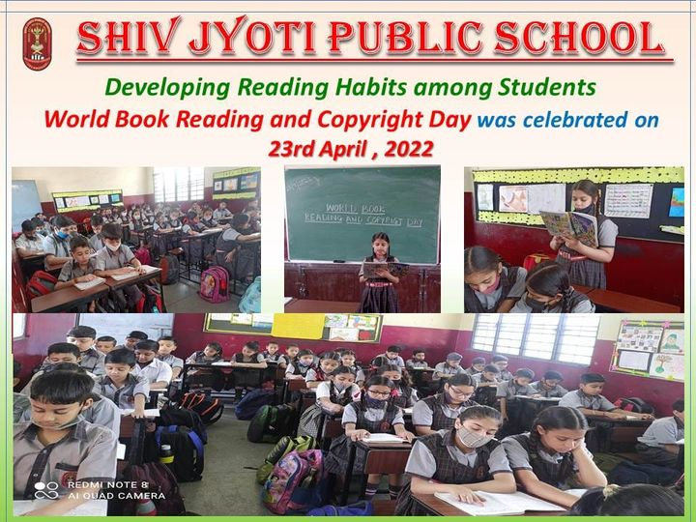
Celebration of World Earth Day
Today is Earth Day, an international event celebrated around the world to pledge support for environmental protection. The year 2022 marks the 52nd anniversary of the annual celebrations. This year theme for Earth Day is ‘Invest In Our Planet ‘.
This day was also observed in Shiv Jyoti Public School. Co-associate Teachers of Kirti House Mrs.Sonia Sharma made the students of classes VII & VIII aware about this day through Video presentation (ppt) on *Inspiring story of Bhutan in conservation of Earth & Recycling of plastic wrappers.*

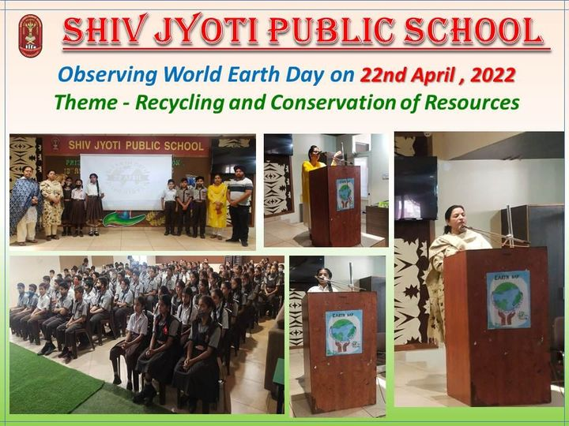

Celebration of 35th Foundation Day
Celebration of 35th Foundation Day of Shiv Jyoti Public School on 13th April 2022-23 with Havan Yajna & Prize Distribution Function

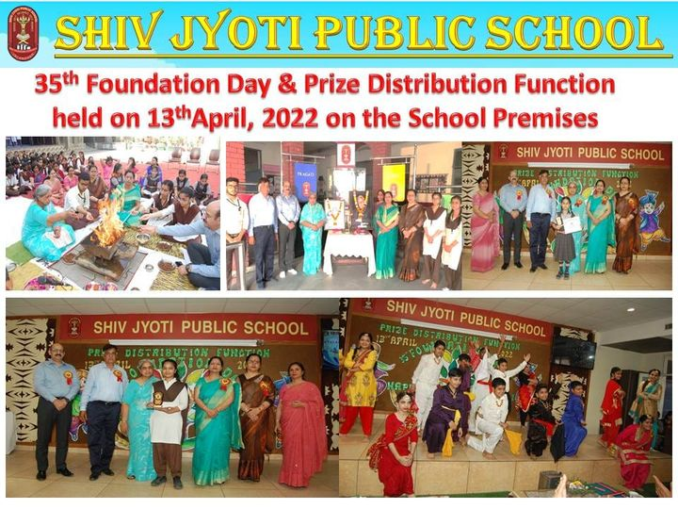
*Celebration of World Health Day
World Health Day is celebrated every year on 7th April to commemorate the anniversary of the founding of the World Health Organization (WHO) in 1948.
The theme for this year’s World Health Day is “Our Planet, Our Health".

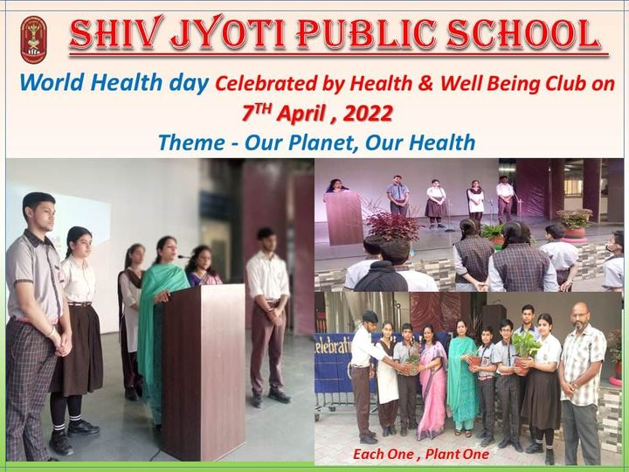
This day was also observed in Shiv Jyoti Public School. Co associate teachers of Health & Well Being club Mrs.Sarita kapoor & Mr.Parminder Vasran made the students of 8th & 9th Class aware about this day in the Special Morning Assembly by showing a video presentation (ppt).by Sadguru to Save the Soil.
Commencement of New Academic Session 2022-23
To seek the blessings of the Almighty on the commencement of New Academic Session on 4th April, 2022, a Special Morning Assembly was organised on the premises of Shiv Jyoti Public School. All the Teachers paid obeisance to Goddess Maa Saraswati & Mrs.Sunanda Sharma recited the mantras.
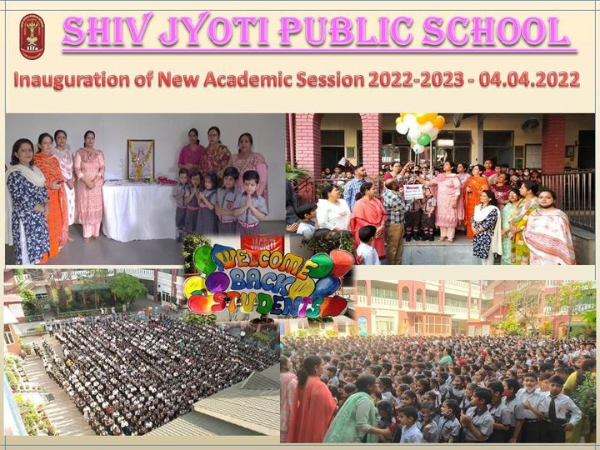

Pariksha Pe Charcha
Live telecast of 'Pariksha pe Charcha 'was arranged for the students of Shiv Jyoti Public School. This year the slogan for ‘PPC 2022’is “Pariksha ki Baat, PM ke Saath “.
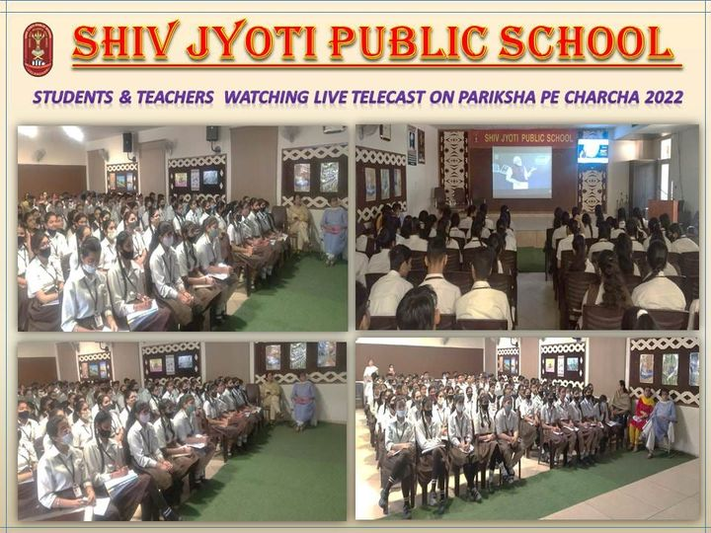
Prime Minister Mr. Narender Modi interacted with students & urged them to have a technology free hour and suggested parents to let children pursue extra curricular activities that they like. PM Modi told parents to inspire children to do things that bring out their inner potential .
Parent Orientation Program
Parent Orientation Program held on 29th March 2022 at Shiv Jyoti Public School. Parents Orientation Programme was conducted for the parents of newly admitted Students. Head of Primary wing Mrs. Ramandeep kaur welcomed all the parents. The Session started with beseeching blessings of Goddess Saraswati and lighting the lamp by the students.
Principal Mrs.Neeru Nayyar apprised the Parents about wellbeing of the Institution & highlighted the values of resilience, aspiration, Determination, tolerance, respect, Mental Well-being etc
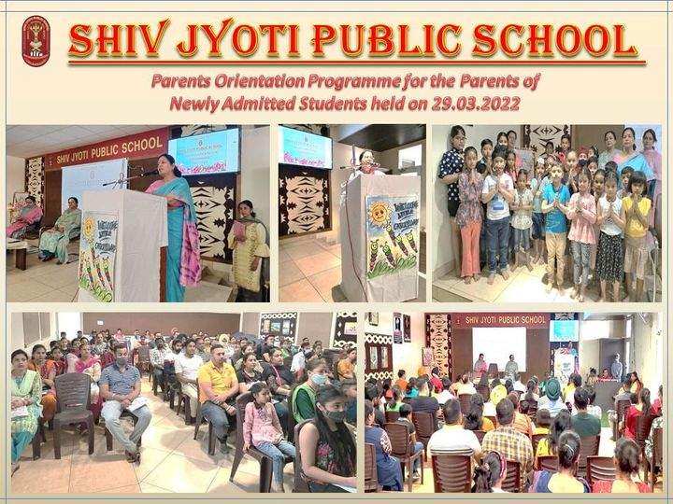
Successful Completion of Third Vaccination Camp
Principal Mrs. Neeru Nayyar motivated the students & Parents to vaccinate themselves.
Around 380 Students & Teachers were successfully vaccinated.

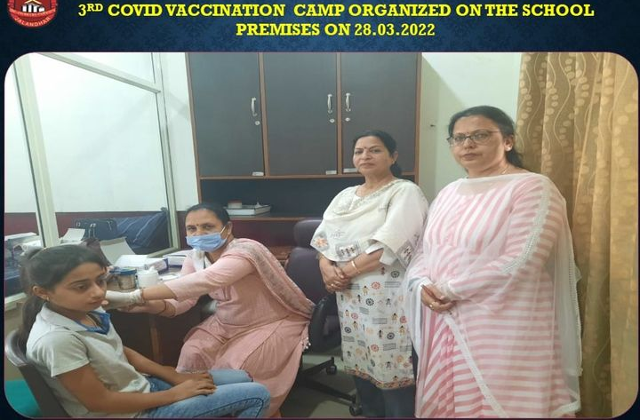

A Tribute to Our Founder Father Revered Late Dr. Durga Dutt Jyoti Ji
Shiv Jyoti Public School observed a day to commemorate the birth anniversary of our Founder Father Revered Late Dr.Durga Dutt Jyoti Ji ,Our Path-Setter, Guide, Pioneer of Women & Value Education, our source of perennial inspiration .All the staff members paid floral tributes to their Founder Father.

