Dance Sports Championship Punjab
Dance Sports Championship Punjab was organised by Dancing Lions School of Performing Art, Jalandhar on 24thApril 2022, powered by Dance Sports Council of India, at Lovely Professional University Punjab.
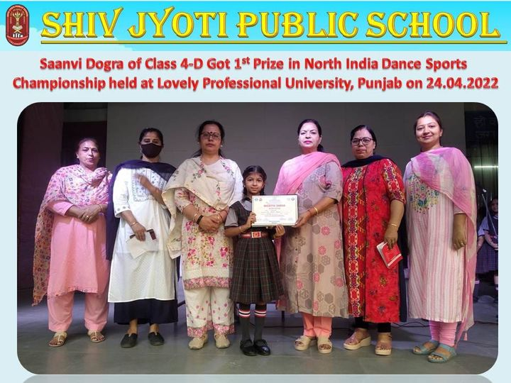
Under the patronage of the School Management, worthy Principal, Mrs. Neeru Nayyar, Saanvi Dogra made the school proud by winning 1st Prize in North India.
Dance Sports Championship Punjab
Dance Sports Championship Punjab was organised by Dancing Lions School of Performing Art,Jalandhar on 24thApril 2022, powered by Dance Sports Council of India,at Lovely Professional University Punjab.
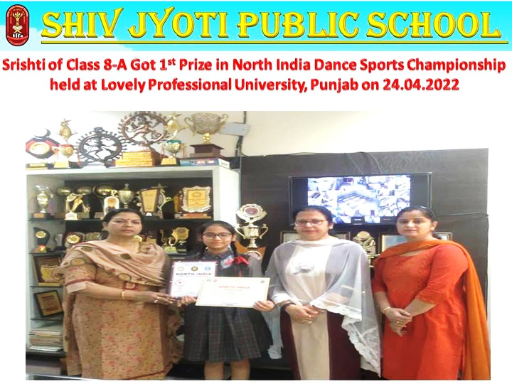
Srishti, a Student of Class VIII A of Shiv Jyoti Public School represented the school in the Jalandhar team under the guidance of her Dance Teachers Mrs. Meenakshi Sharma & Mrs. Rajni Sharma.
Under the patronage of the School Management, worthy Principal, Mrs. Neeru Nayyar, Srishti made the school proud by winning 1st Prize in North India.
Jalandhar Sahodaya Inter School Face Painting Competition
Under the aegis of Jalandhar Sahodaya, Inter School Face Painting Competition was hosted by DAVDRV Cenetary Public School Phillaur,Jalandhar on 29/4/22 for Classes Vl to Vlll
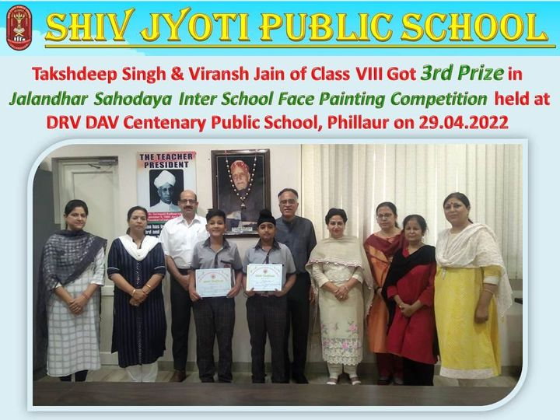
Under the patronage of the School Management, Worthy Principal, Mrs. Neeru Nayyar, Takshdeep Singh (Artist) & Viransh Jain (Model)of Class VIII made the school proud by winning Third prize under the theme-‘Life below Water’.

