Plantation Drive by tagging the name of Plants of Pairing States Andhra Pradesh & Punjab under EBSB

Under Ek Bharat Shreshth Bharat programme launched by CBSE, Shiv Jyoti Public School organised plantation drive by tagging the name & uses of the plants/ tree planted in the Language of Punjabi & Telugu in which around more than 400 students along with co -associate Teacher Ms. Sapna & Ms. Sandeep Saini took part enthusiastically.

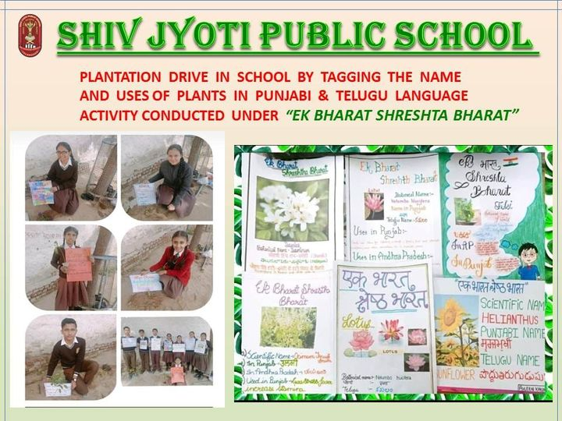

Learning of Indigenous Sports of Pairing States Andhra Pradesh & Punjab under EBSB
Shiv Jyoti Public School organised Indigenous Sports for Students of Classes 8th to 12th. The Students were encouraged to play Kho -Kho, Kabaddi, Seven Stones , Chain-Chain & Tug of War etc.

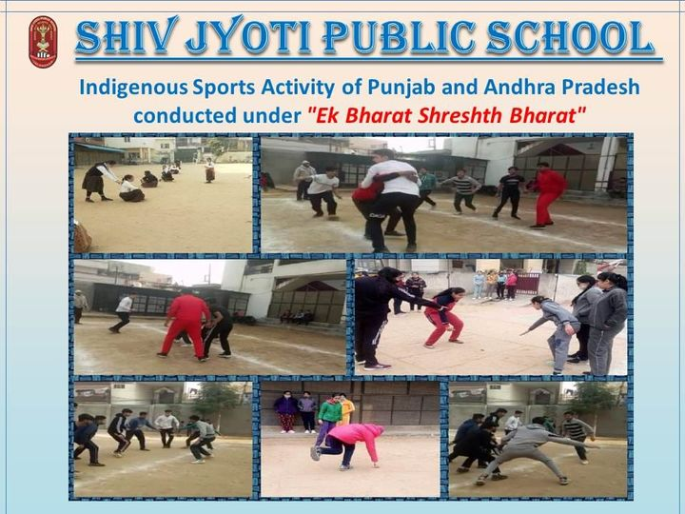

Awareness Programme on National Science Day
National Science Day is celebrated every year on February 28. This day recalls the notable invention “Raman Effect “by India’s greatest scientist Sir C.V Raman. The theme for 2022 is “Integrated Approach in Science & Technology for a Sustainable Future “.Poem writing activity was also performed by Students on this day.

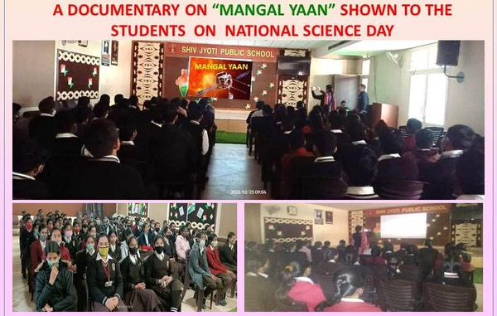
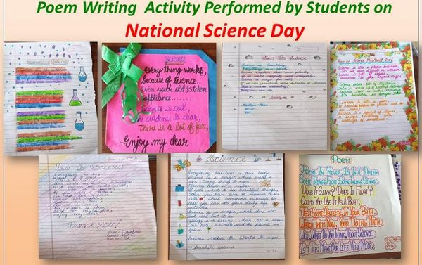

Adolescent Peer Educators Leadership in life skill ,Health & Well Being Program

Health and well Being club of Shiv Jyoti Public School conducted Theme 1 (Adolescence & Mental Health ) Module 1 ,Under 'Peer Life Skills Leadership Program in Life Skills, Holistic Health & Well-being' ,Program proposed by CBSE ,under the able leadership of the school management and Principal Mrs. Neeru Nayyar. 90 students participated in this activity.

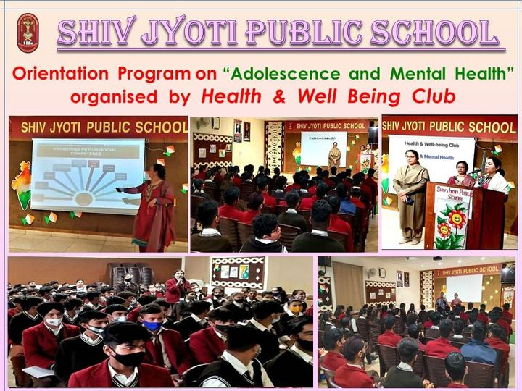

Under this activity, Mrs.Sarita Kapoor made students aware that a well-balanced person can face all emotions like fear, anger, guilt, shame, Loneliness through core life skills. There is distress in stress but there should be no depression.
Learning of Folk Painting of Pairing States Andhra Pradesh & Punjab

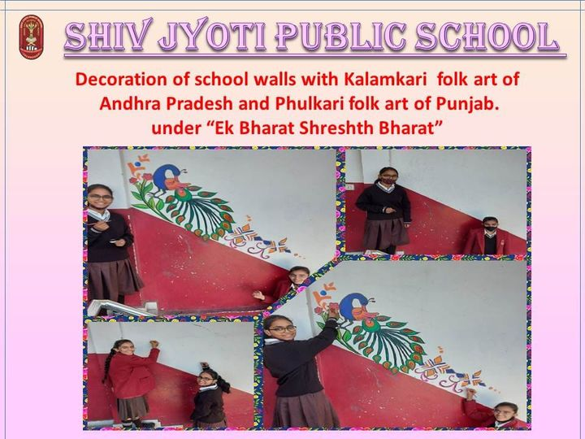
Under Ek Bharat Shreshth Bharat programme launched by CBSE, Shiv Jyoti Public School organised Phulkari & Kalamkari art -Learning of Folk painting for Students of Class IX in which around more than 80 students along with co -associate Teacher Ms.Rajni Malik took part enthusiastically.

Celebration of World Peace and Understanding Day on 23rd February 2022

World Peace and Understanding Day has a motto that stands for “Service above Self". The day is celebrated across the world on 23 February , 2022 every year with the thought of understanding amongst people and sharing life values to maintain peace and harmony.

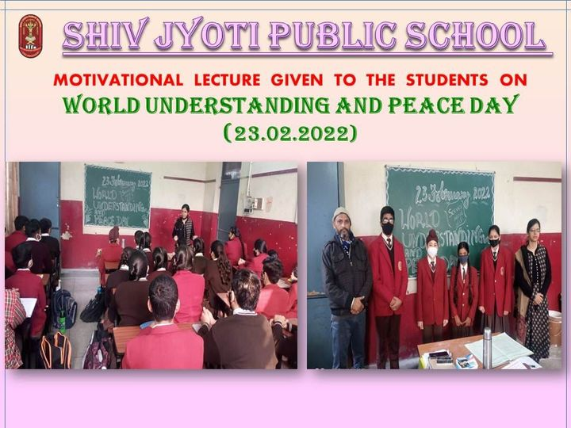

Celebration of International Mother Language Day
International Mother Language Day is observed worldwide on 21st February every year to promote awareness of linguistic & cultural diversity & to promote multilingualism.
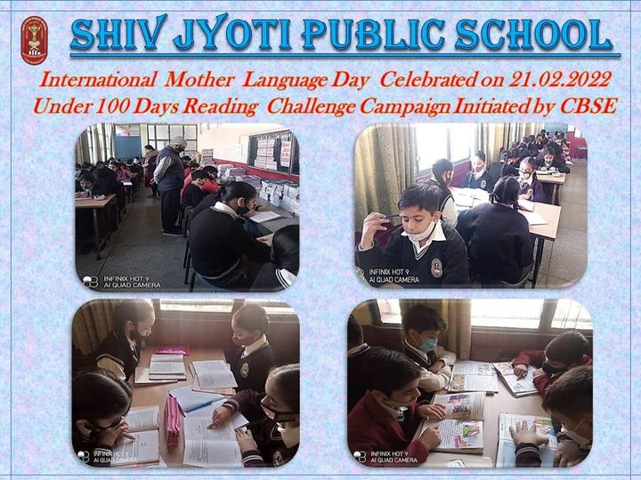
This Day was also observed in Shiv Jyoti Public School Under 100 Days Reading Challenge Campaign being initiated by CBSE of week 8. Around 40 students of class 6th participated in the Activity. Students read stories in their mother tongue and wrote reviews individually.

Celebrating Basant Panchmi
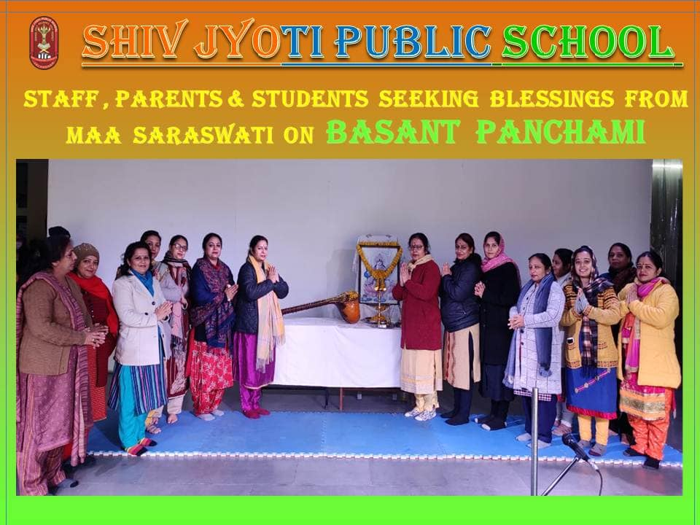
73rd Republic Day Celebration
To commemorate 73rd Republic Day on 26 January,2022 Flag Hoisting ceremony was held on the premises of Shiv Jyoti Public School.
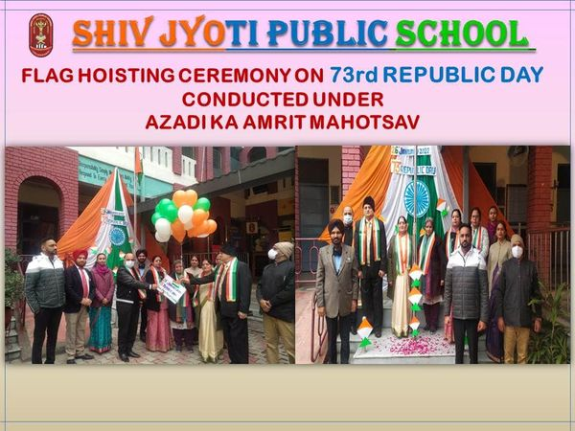
Students of the school mesmerized the audience with Yoga Asanas (Surya Namaskar) prepared by Mrs. Zenith & Mr. Nirmal Singh followed by Medley of patriotic songs where students mesmerized every one with their performance full of patriotic zeal & vigor prepared by Mrs. Rekha Joshi & Mrs. Sunanda Sharma.
Further attraction of the event was Video Enactment (ppt)prepared by the Students on our Cultural Heritage & National War Memorials under the guidance of Mrs. Simmi Grover, Mrs.Aarti Tandon, Mrs.Neeraj Sehgal ,Mrs. Sonia Sharma.
Inter House English Declamation Competition
As per CBSE guidelines Under 75th Azadi ka Amrit Mahotsava to celebrate Republic Day of our nation various activities are being organised to apprise the students with their glorious heritage. In this series Inter House English Declamation Competition for classes 3rd to 5th was held on 21/1/ 2022.
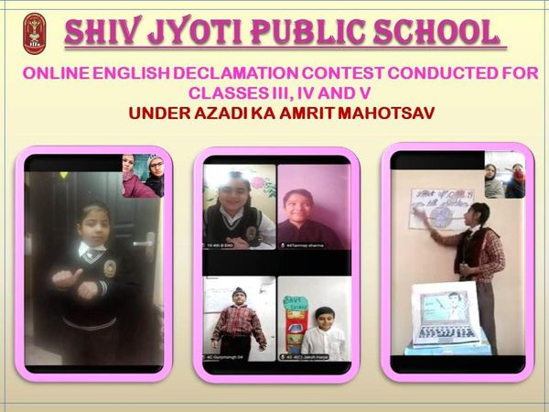
Inter House Hindi Poem Recitation Competition
As per CBSE guidelines, Poem recitation activity Under 75th Azadi ka Amrit Mahotsava, various activities were organised for the celebration of Republic Day
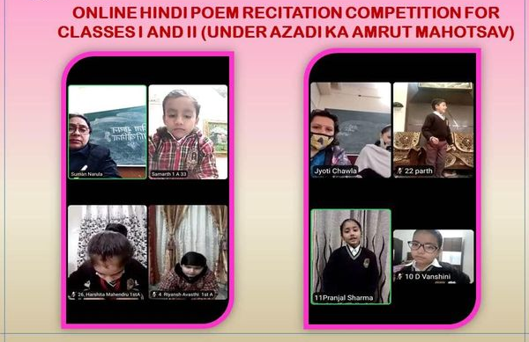
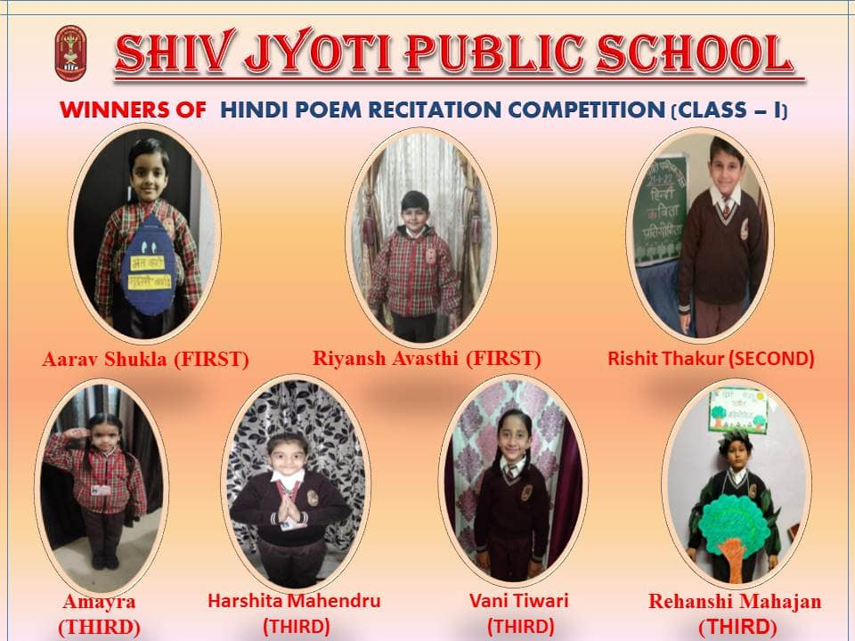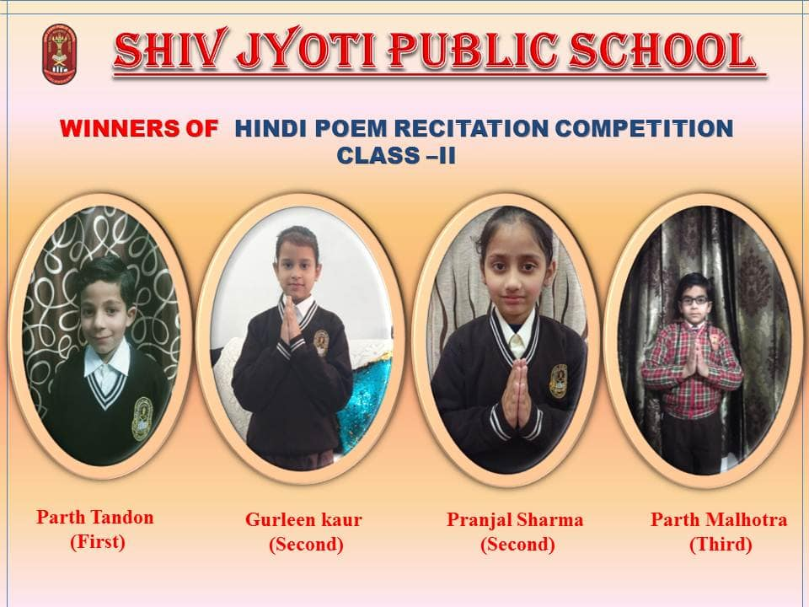
Successful Completion of a Three -Day Vaccination (Covaxin) Camp
During this period of pandemic, keeping in view the safety of the school children in mind, COVID Vaccination Camp was organised in Shiv Jyoti Public School for Students between the age group of 15-18 years for the Classes 9th to 12th.This camp continued for three days from 20/1/22 to 22/1/22.
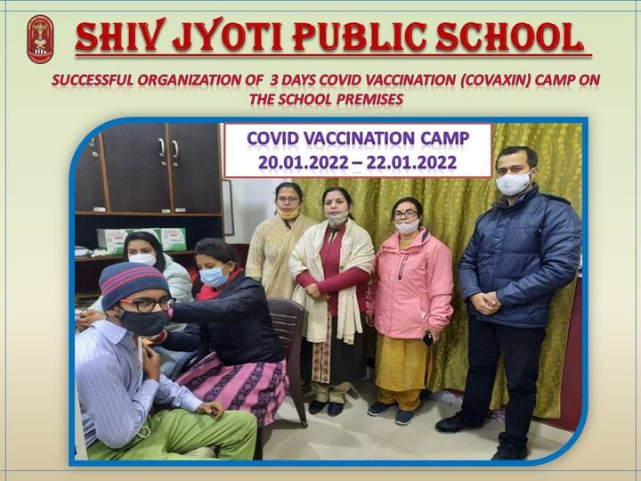

An Essay Writing Competition
Under Ek Bharat Shreshth Bharat programme launched by CBSE, Shiv Jyoti Public School organised an English Essay Writing Competition.

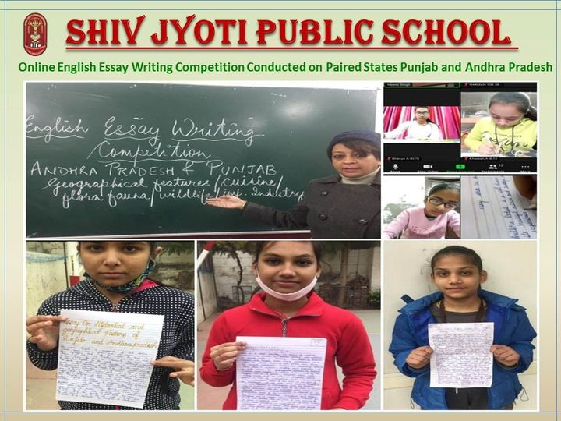
Under Ek Bharat Shreshth Bharat programme launched by CBSE, Shiv Jyoti Public School organised an English Essay Writing Competition for Students of Class X in which around more than 80 students along with co associate Teacher of Pragati House ,Mrs.Neenu Singh took part enthusiastically.
Celebration of National Youth Day on 12 January

In 1985, the Govt. of India declared Swami Vivekananda ‘s Birthday January 12th as National Youth Day in honor of the great philosopher & monk.
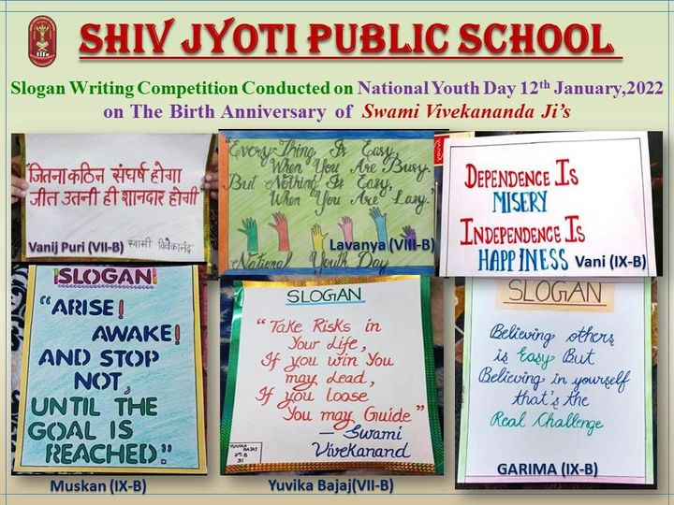
Students of Classes 6th to 9th were made to write *Slogans* on the philosophies & ideals of Swamiji & were made aware about this day through the medium of video presentation (ppt). Students Hisha -(8th-D) & Bhawni (9-C) and Co -associate Teachers Mrs. Sapna, Mrs. Palwinder kaur & Mrs. Ranju Sharma participated in the Activity with full enthusiasm.
Annual Sports Meet
Under the able guidance of the School Management & Principal Mrs. Neeru Nayyar, Shiv Jyoti Public School provides platform to its students to take part in various activities. Our school celebrated its Annual Sports Day
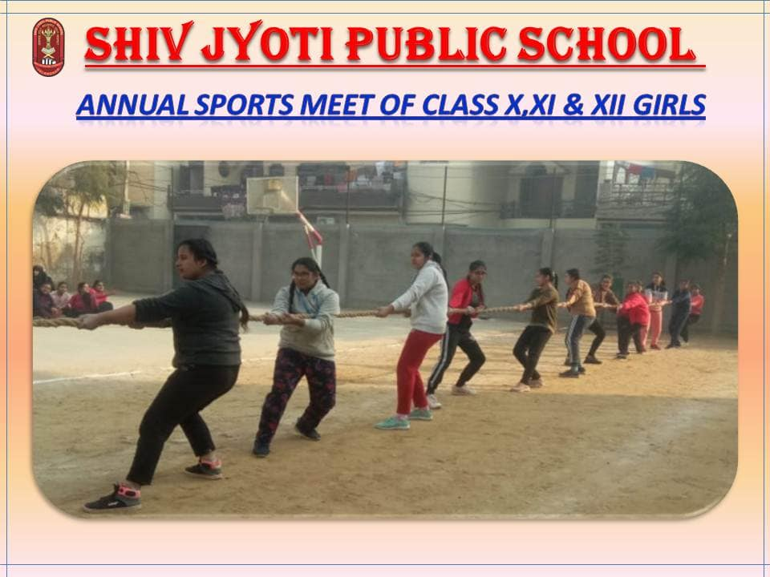
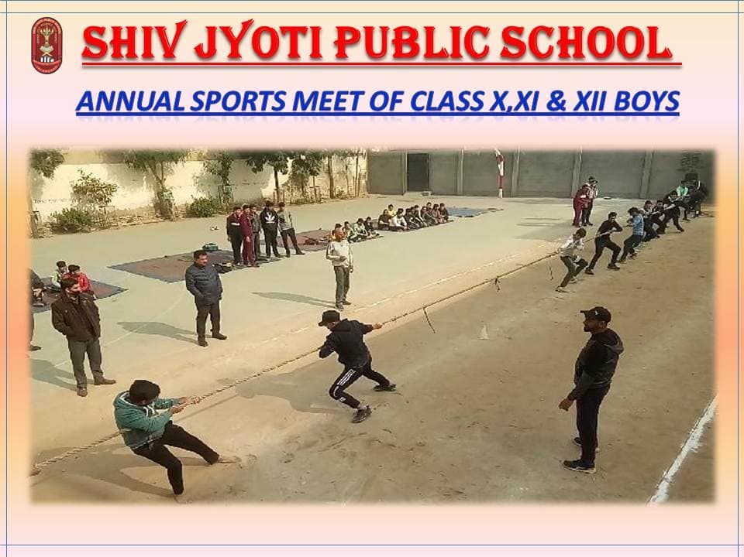
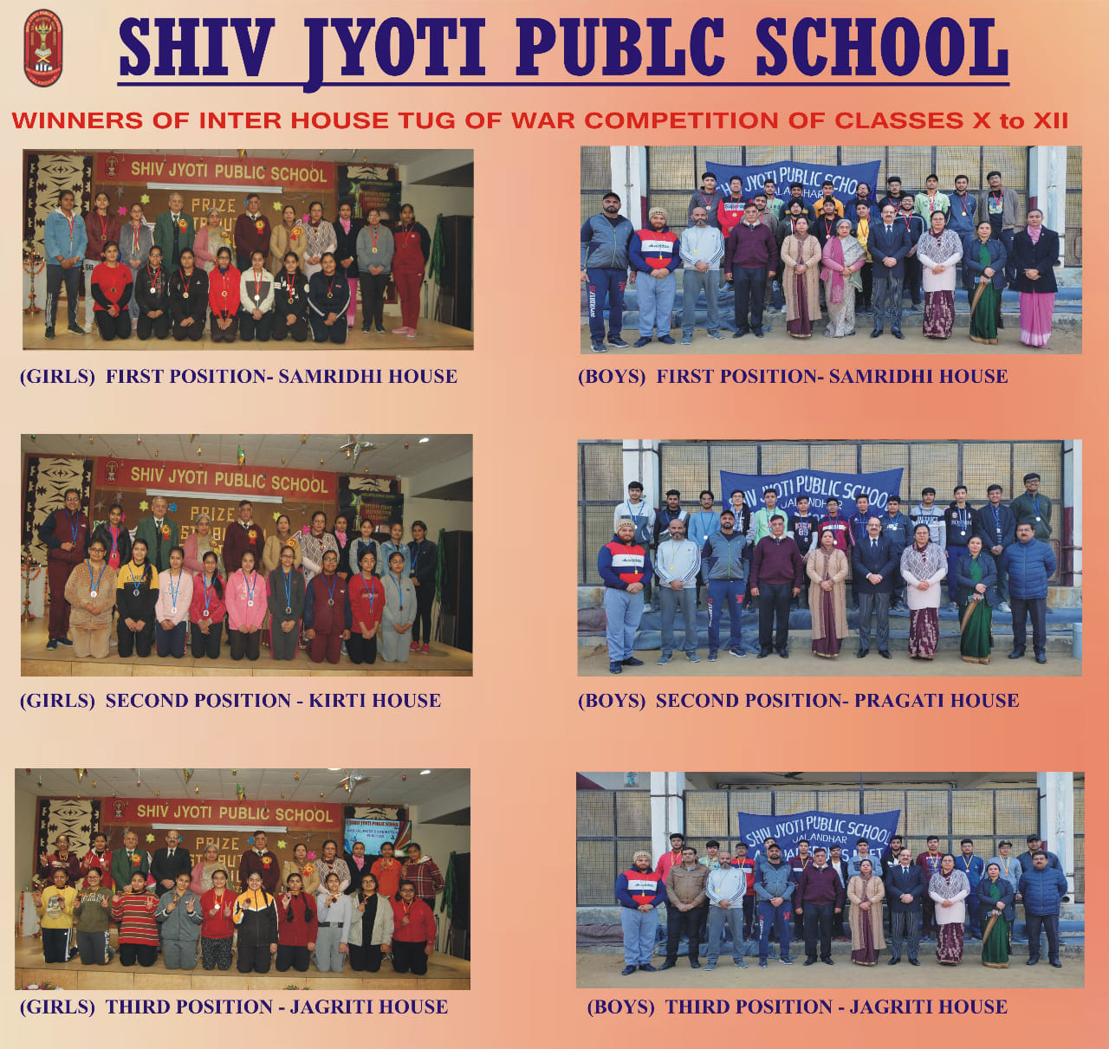
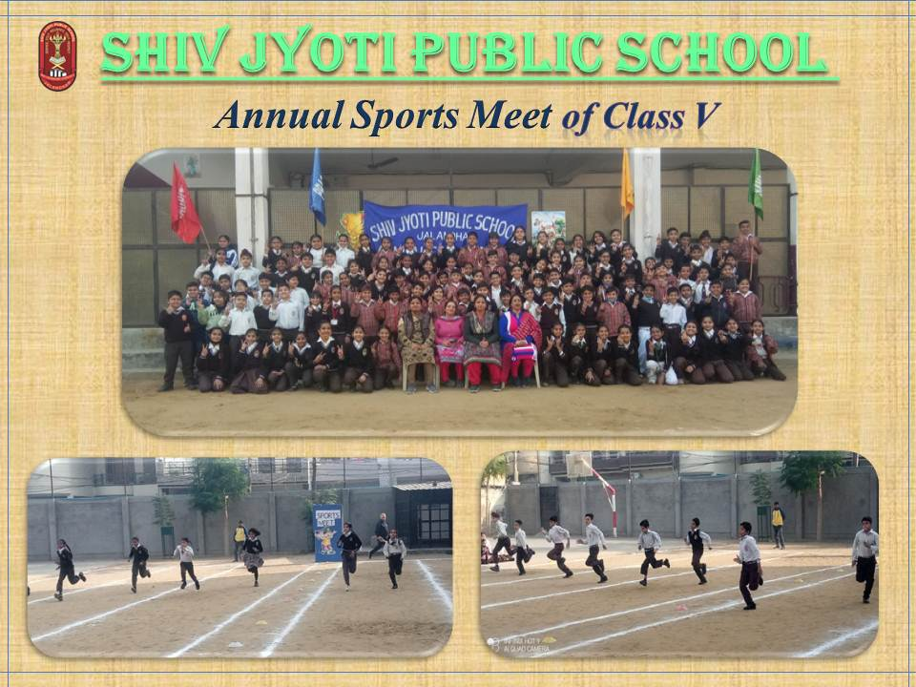
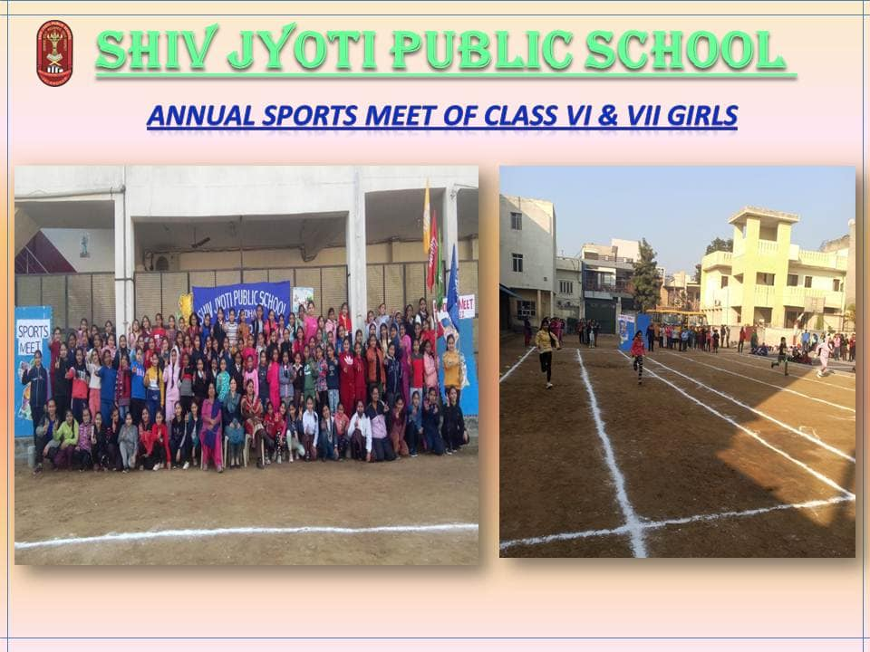

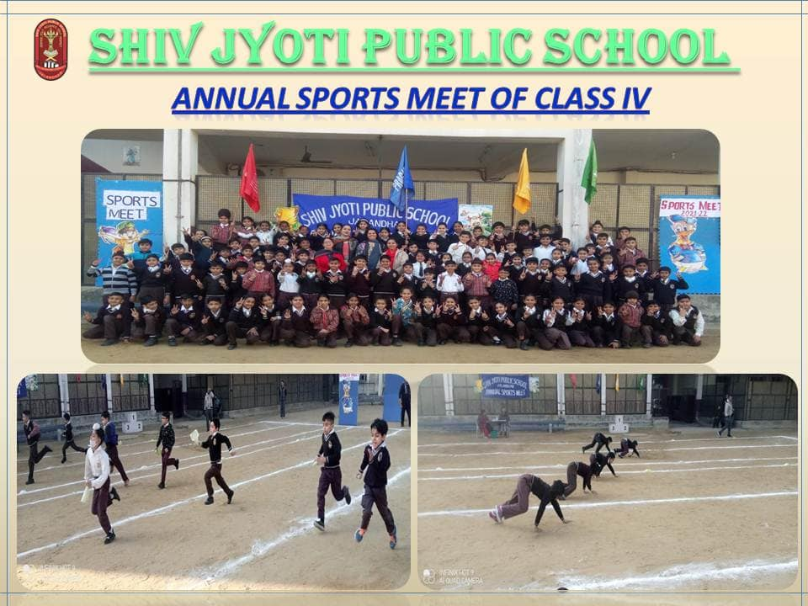
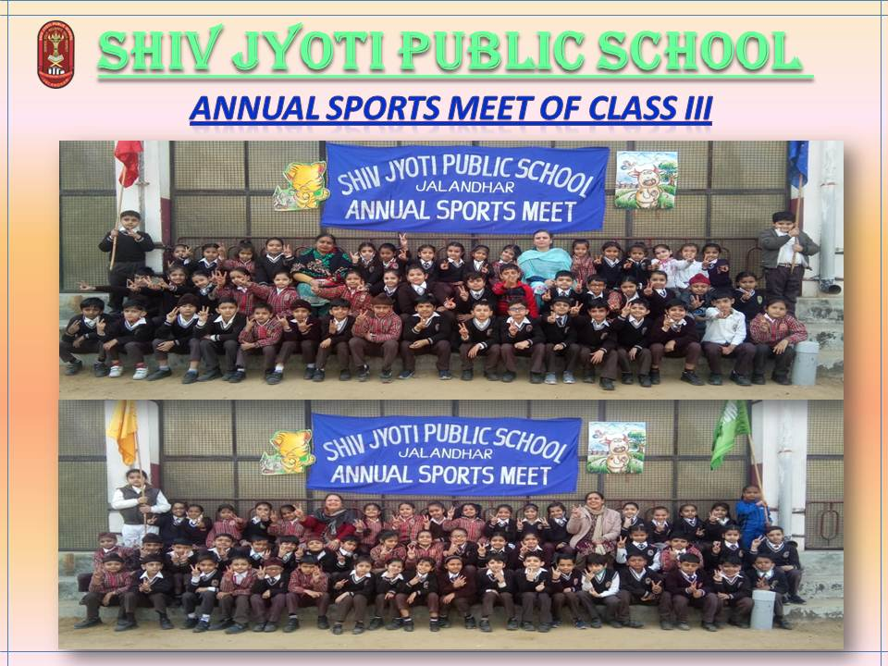
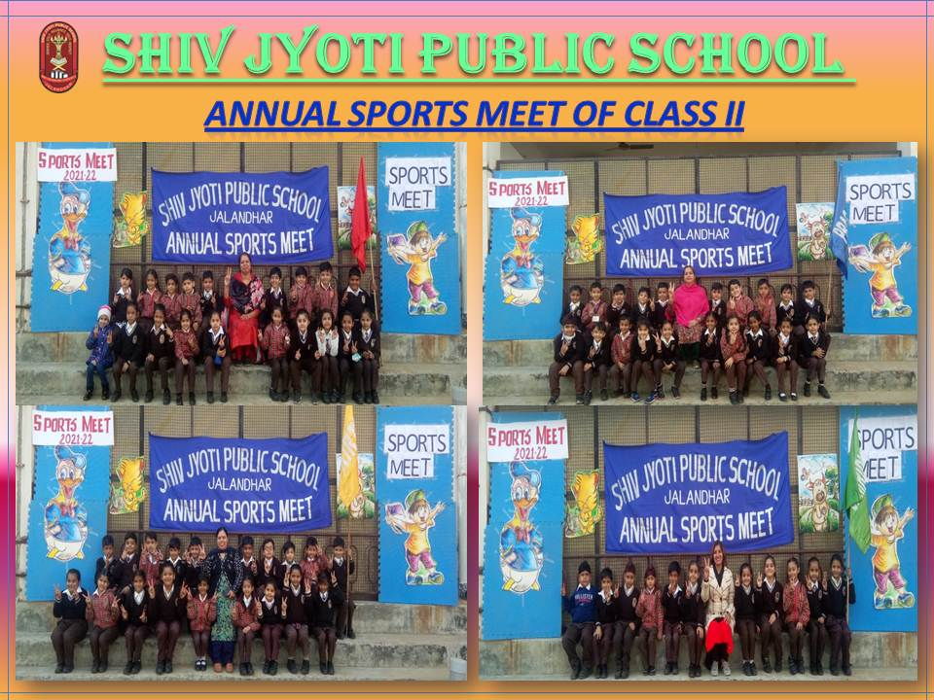
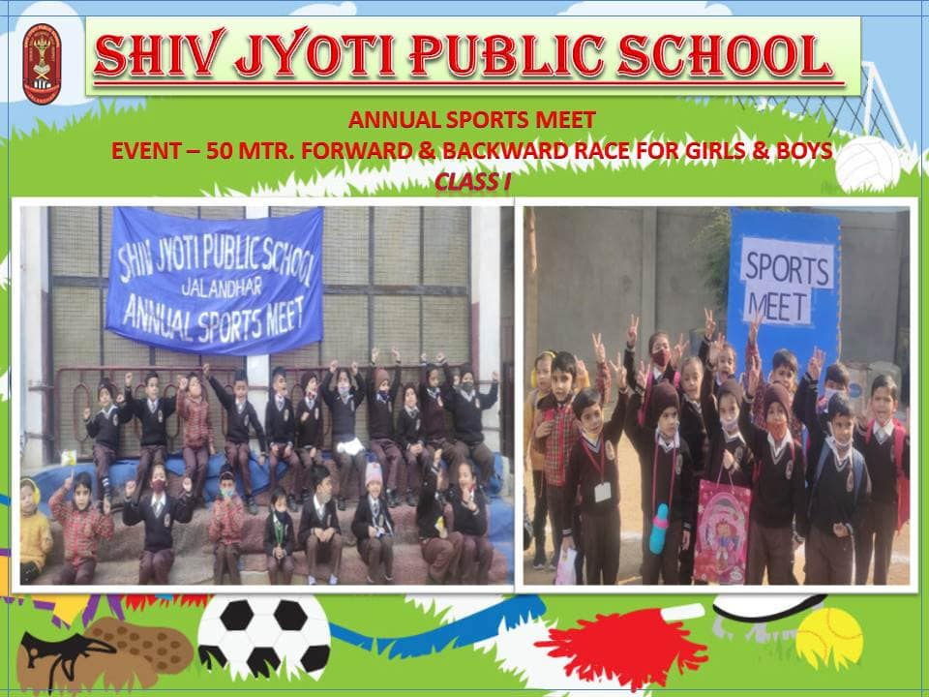

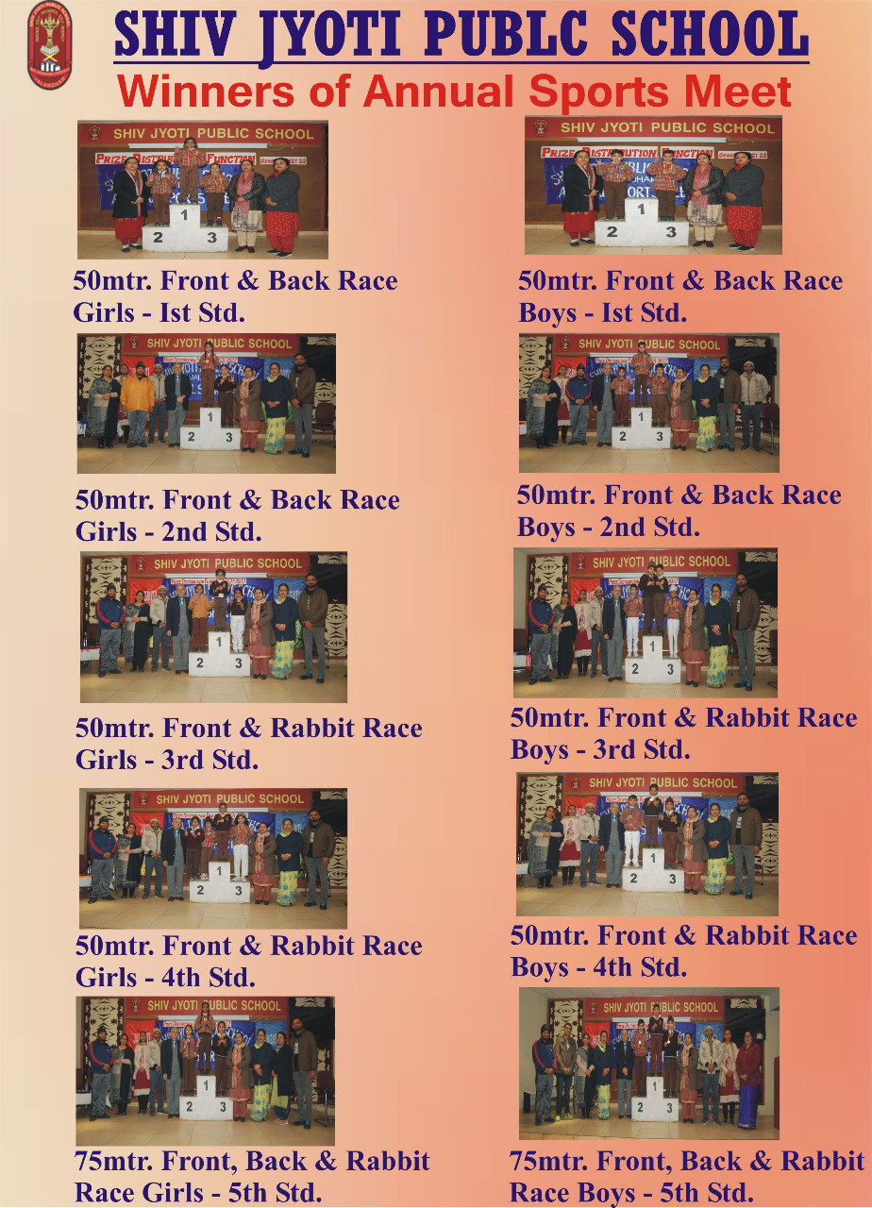
32nd Annual Prize Distribution Function
To felicitate the meritorious students of Classes V to X in Academics & Cent percent attendance awards for the session (2019-20) 32nd Annual Prize Distribution Function was held on the premises of Shiv Jyoti Public School on 22nd December, 2021,
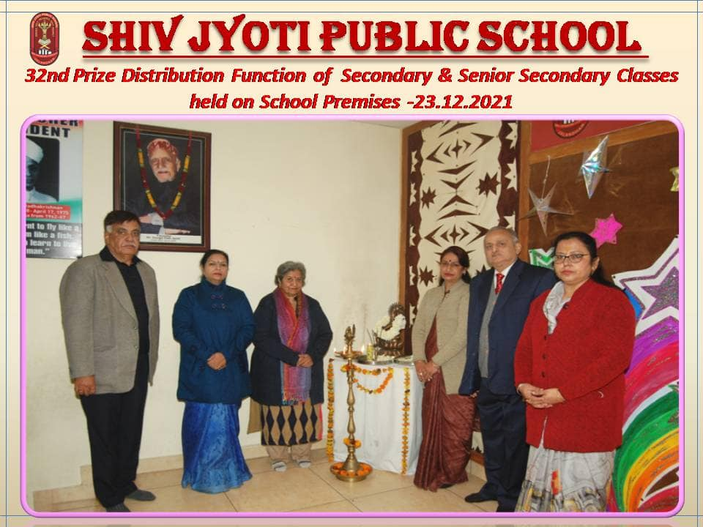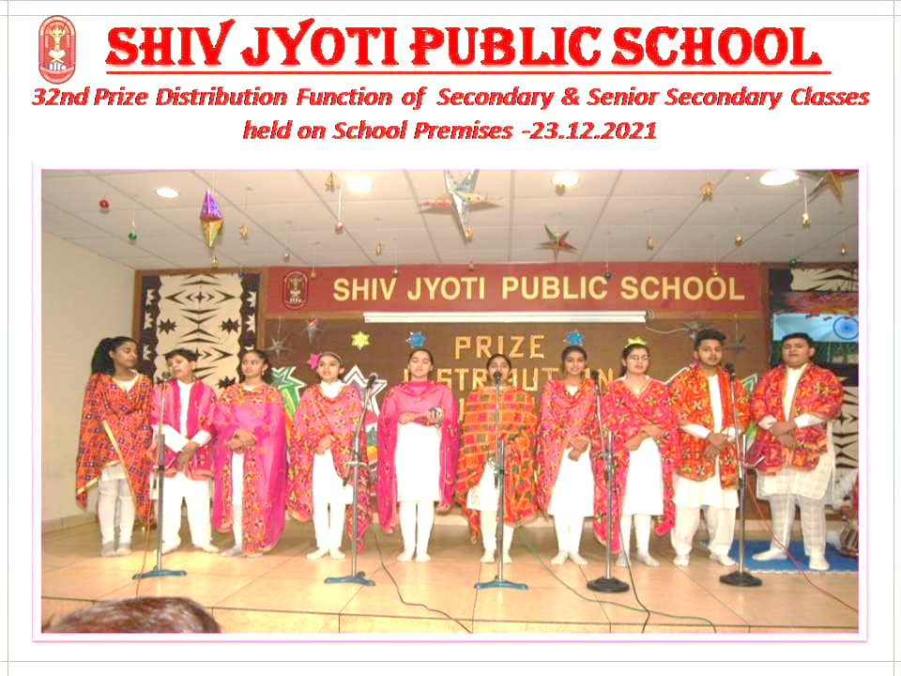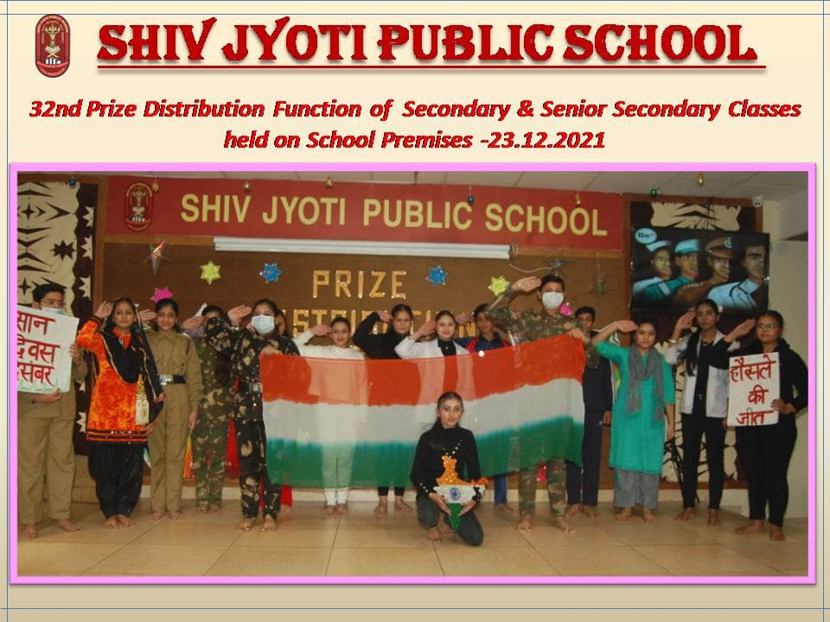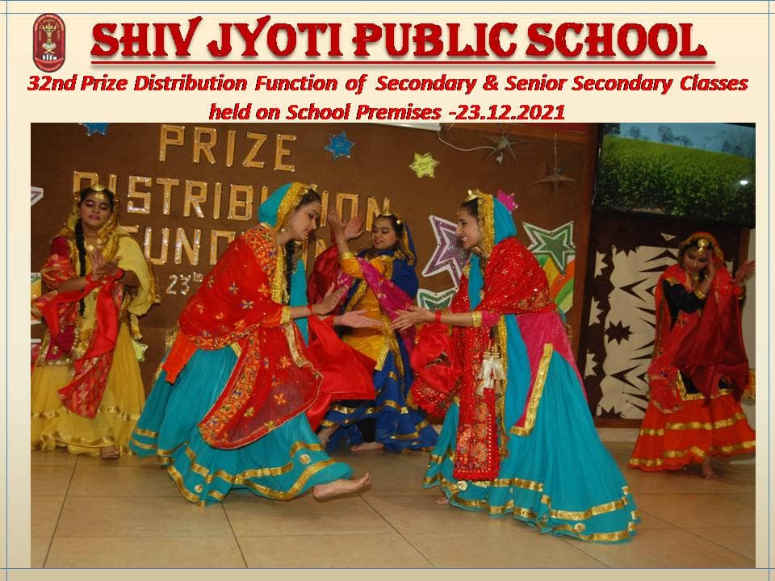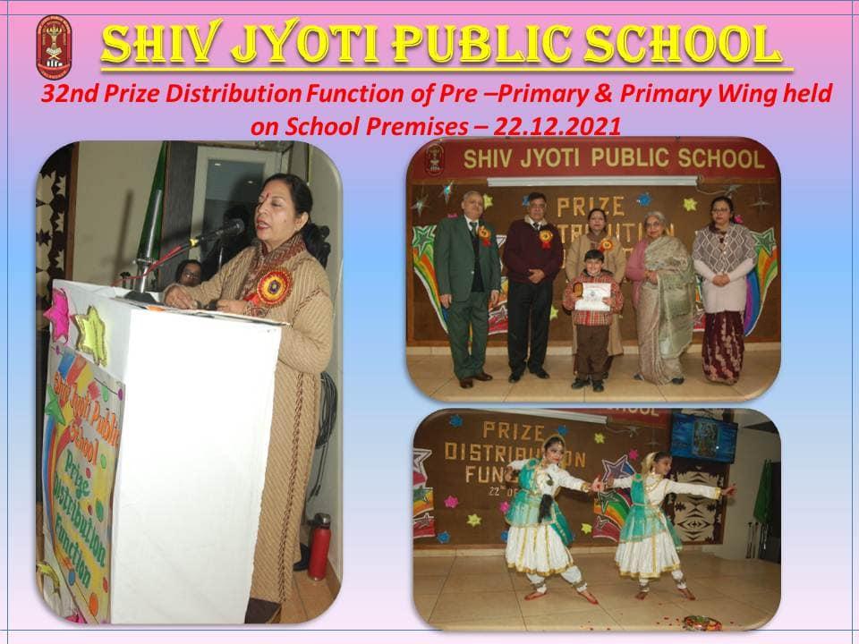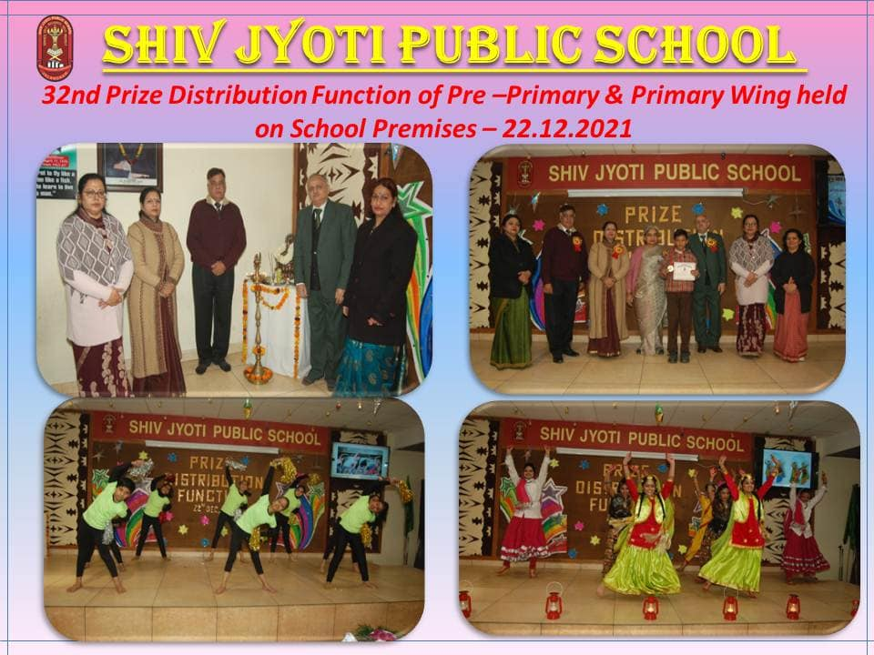

75 Lakh Post Card Campaign
As a part of ongoing celebrations of Azadi ka Amrut Mahotsav(AKAM) Department of Posts, Ministry of Education along with the department of School Education, Post Card Campaign was held on 17.12.2021.Around 800 students participated in the event .Students shared their views with Hon'ble Prime Minister through Post Cards
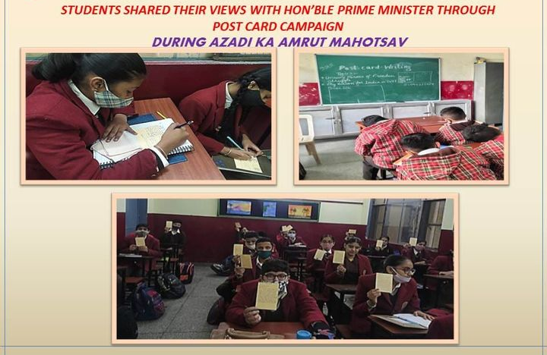Inter House English Debate Competition
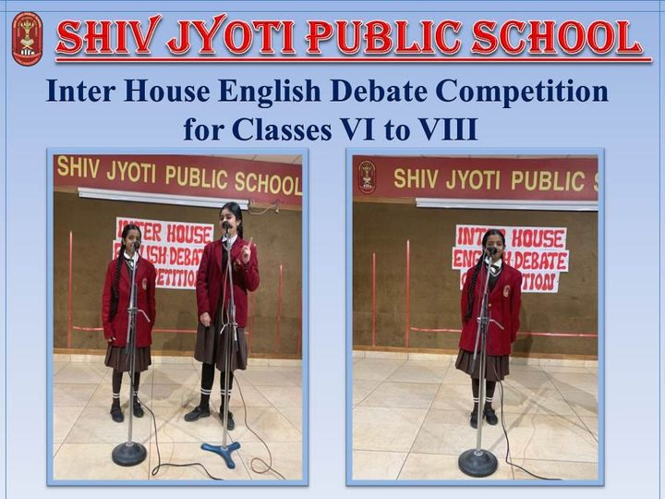
Inter House English Debate Competition for classes 6th to 8th was held .The topics were: Is online Education better than Traditional Education & Shreshtha Bharat.The participants put forth their enthralling performance. Participants were shortlisted for the same by Mrs. Savita Sharma for class 6th, Mrs. Shashi Dubey for class 7th, Mrs.Ritu Devgun for class 8th .The Final judgement was made by Mrs. Richa Sharma & Mrs.Pooja Sodhi.

