Punjab State Fencing Championship U-14/17 Boys & Girls
Punjab State Fencing Championship U-14/17 Boys & Girls was organised by Jalandhar District Fencing Association at St. Soldier Group of Institution from 26th to 28th February. 2022 .
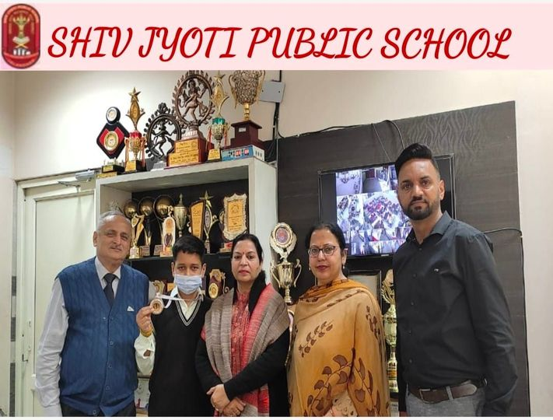

Ansh Shori , a Student of Class VII of Shiv Jyoti Public School represented the school in the Jalandhar team under the guidance of her Physical Education Teacher Mr Nirmaljit Singh.
Inspire Manak Awards 2021-22
Government of India Ministry of Science & Technology, Department of Science & Technology under the INSPIRE Award scheme for the year 2021-22 invited innovative ideas on Science based Projects on different themes.
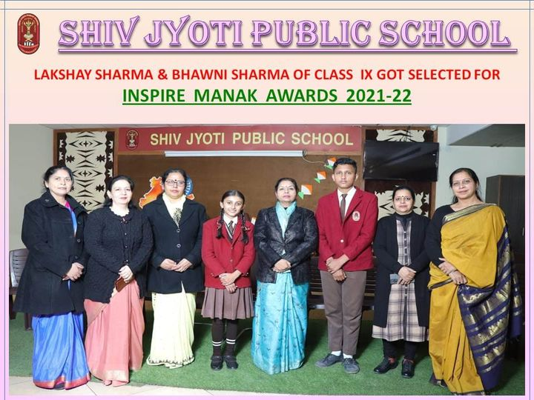
Five students of our school participated in the event under the guidance of our Science faculty members Mrs. Latika Sharma, Mrs. Sandeep Saini, Mrs. Sapna Vaid & Mrs. Ritu Grover and two of them. Lakshay Sharma (9th-E) & Bhawni Sharma (9th-C) made the school proud by winning cash prize of Rs10,000 each for preparation of their Projects based on Environment safety and utility of Bio waste for the next level round.
All India Sports Dance 2021
Dance Sports Council of India and Dancing Lions School of Performing Arts, council of Punjab organised All India Sports Dance 2021 that was hosted by Lovely Professional University Phagwara, Jalandhar Punjab.
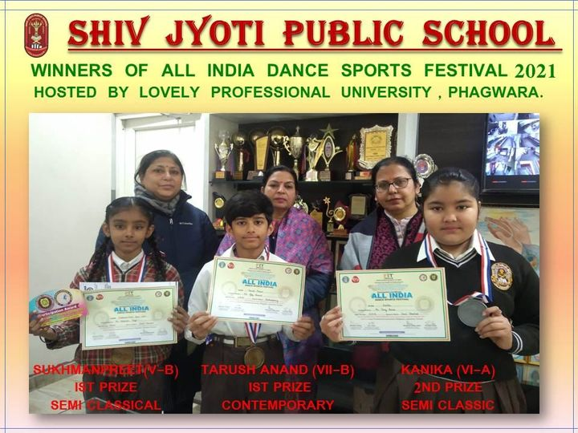
Our school students participated in the event and grabbed various positions in this competition. Sukhmanpreet of class V grabbed first position in Semi-Classical Dance under the age group of 8 to 10 years. Kanika of a class VI bagged second position in Semi Classical Dance under category of 10 to 13 years. Tarush Anand of 7th class has got first position in Contemporary Dance Style under the age group of 10 to 13 years.
Jalandhar Sahodaya Online Inter School Poster Making & Slogan Writing Competition
Under the aegis of Jalandhar Sahodaya Online Inter School Poster Making & Slogan Writing Competition was hosted by Sanskriti KMV School, Jalandhar.Students of Shiv Jyoti Public School participated in the event under the guidance of their Art & Craft Teachers Ms. Rajni Malik & Mrs. Kiran Sharma & Activity Coordinator Mrs.Bhavna Sabharwal to show their best potential. 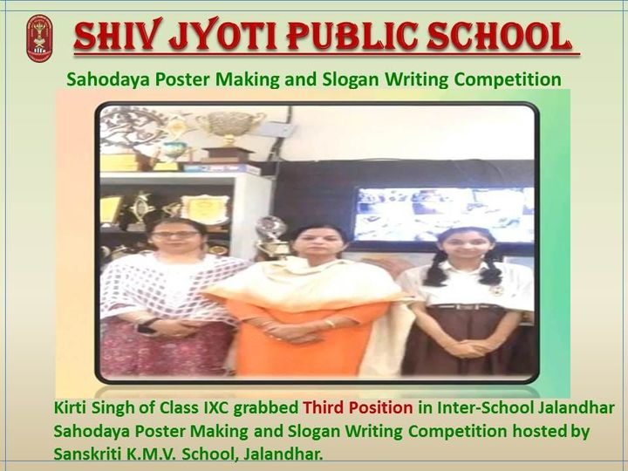Under the patronage of the School Management, worthy Principal, Mrs. Neeru Nayyar, Kirti Singh of Class IX made the school proud by winning Third prize under Category-2,under the theme-Yoga & Meditation.
1st Punjab State Floor Curling Championship 2021-22
during this period of pandemic Shiv Jyoti Public School provides platform not only to its students but also to their faculty members to take part in various activities

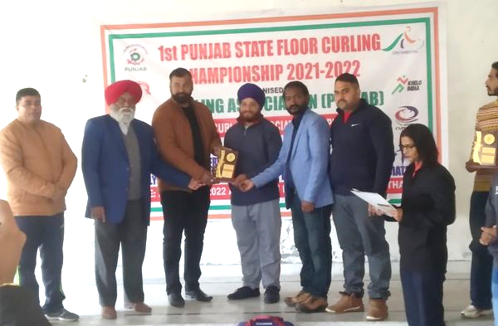

Curling Federation to India World Curling Federation India organised 1st Punjab State Floor Curling National Championship 2021-22 that was organised at Gulmarg (Srinagar) , Mr.Nirmal Singh (Physical Education Teacher) was selected for National Championship .
Moreover Mr.Nirmal Singh was presented AP Drona Physical Education Award (2021) on 26 December 2021 for his hard work, dedication & untiring efforts for the upliftment of Physical Education & Sports.

